Python has been used worldwide for different fields such as making websites, artificial intelligence and much more. But to make all of this possible, Data is an important aspect when it comes to programming storing it in the right way and managing it makes it easier to access and perform operations on so how do we achieve this we use something called as data structures.

What is Data Structure
A data structure is a particular way of organizing data in a computer so that it can be used effectively. Data structures means how you are storing your data. The way of organizing a data in a particular manner. Organizing, managing and storing data is important as it enables easier access and efficient modifications. Data Structures allows you to organize your data in such a way that enables you to store collections of data, relate them and perform operations on them accordingly.

Why we need data structures?
- Allows us to manage large amount of data
- Allows data to be stored in a specific manner
- Allows us to search data
- Allows us to insert new data
- Allows us to read data
- Allows us to delete data

Types of Data Structures in Python
- Built-In Data Structures
- User-Defined Data Structures
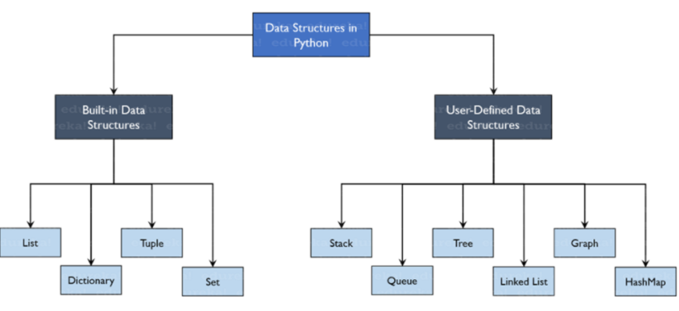
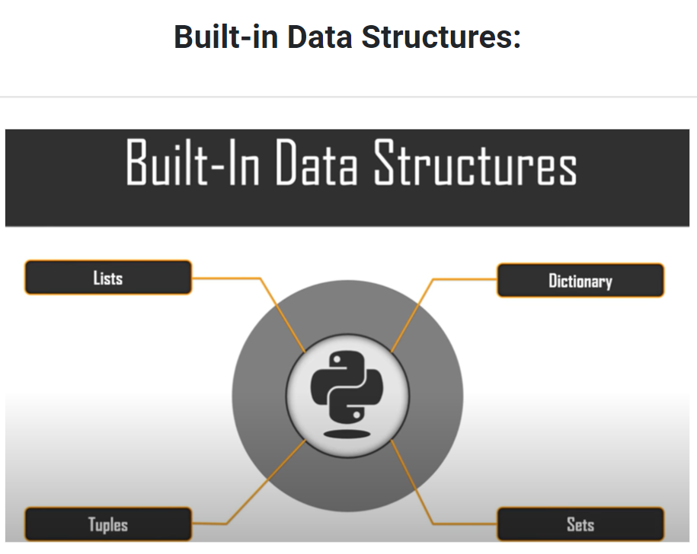
As the name suggests, these Data Structures are built-in with python which makes programming easier and helps programmer use them to obtain solutions faster. There are four built-in data structure (collection type) in the Python programming language:
- List is a collection which is ordered and changeable. Allows duplicate members.
- Tuple is a collection which is ordered and unchangeable. Allows duplicate members.
- Set is a collection which is unordered, unchangeable*, and unindexed. No duplicate members.
- Dictionary is a collection which is unordered** and changeable. No duplicate members.

